Esports Earnings 1998-2019

Diogo Andrade 89265, Rodrigo Oliveira 90514

Information Visualization, 2019 (MEI, University of Aveiro)

Abstract

For the practical assignment of the Information Visualization class, the proposal was to develop a visual data exploration application based on a chosen theme and using the d3.js library. The final expected product would be a website that allows the user to interact with the developed data visualizations. Our chosen theme was Esports Earnings from videogame tournaments from 1998 to 2019.

# Motivation and objectives

The motivation behind this work was being able to put in practice the knowledge acquired in the Inf. Vis. Classes in an interesting and interactive fashion, which is where the d3.js library comes in. It was also an opportunity to present a theme and dataset that we consider interesting as competitive videogames are a growing sport and we took this opportunity to develop an app that allows users to visualize the evolution of the amounts of money that has been on offer as tournament prize pools over the years.

# Users and the Questions

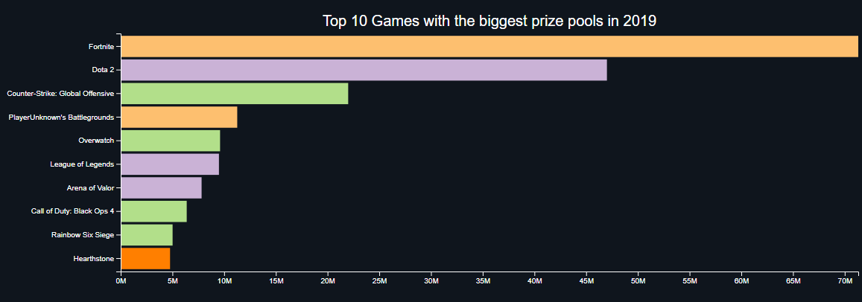The target users for our application are investors, looking into learning which videogames are the most profitable possibly for an investment opportunity either in a sponsorship for a team or for a tournament, uninformed members of the general public, meaning either parents or people that aren’t into videogames, looking to find out what kinds of videogames people are making money from playing competitively or just general fans of videogames and esports looking to know more about the evolution of the competition prize pools over the years.

## Characterization of the users and their context

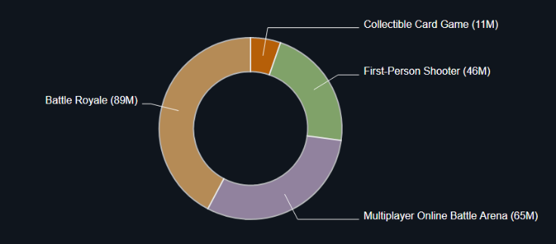Michael Edwards, 43, CEO of a successful company, is looking to find out more about the world of Esports and competitive gaming. He is considering buying shares in an esports organization but before choosing which one, he wants to analyze what the current situation in esports is regarding the most recent data and tournament prize pools.

Sophie Evans, 52, mother of 2 boys, aged 14 and 17, who love videogames and have just told their mom about esports, a rising sporting category where the athletes can earn a lot of money. Skeptical about this information, she wants to learn what kind of values are involved in these tournaments’ prize pools and what kind of games esports athletes are playing in them.

Joe Smith, 19, student and videogame and esports afficionado, just watched a video about an esports tournament from 2004 and having seen how different things were back then, he’s wondering what kind of values the prize pools of the tournaments were back in that time and even before, so he wants to check, from 2000 to 2007, what kind of videogames were the most profitable to play competitively.

## Questions to Answer

Michael asks: What were the 3 videogames with the biggest prize pools last year (2019)?

In our homepage, Michael can find data about the top videogames with the biggest prize pools, right in our first bar graph in the page and he will find that the top 3 videogames of 2019 were Fortnite, Dota 2 and Counter-Strike Global Offensive.

He also asks: What genres were the ones with the biggest prize pools last year?

Again, in our homepage, he can also find data about the top genres with the biggest prize pools, this time in our circle graph and he will find out that the top genres in 2019 were Battle Royale and MOBA

Sophie asks: What are the videogames that esports athletes are playing in these tournaments?

In the same graph where Michael found out about the top videogames with the biggest prize pools, by hovering over the bars, Sophie can find out more info about the games in the graph, for example Fortnite

Joe asks: What were the dominating genres regarding prize pools in the period of 2000-2007?

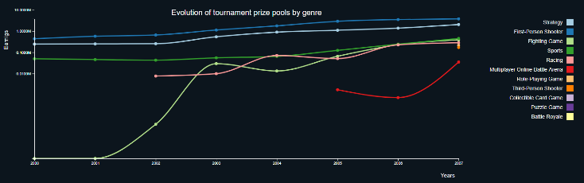 In our Graphics page, Joe can set the period to 2000-2007 using the slider and the graph will update to the data from that period. He will find out that the top genres from that period were First Person Shooters and Strategy games.

# Dataset

The chosen dataset was found in Kaggle and is titled “Esports Earnings 1998 – 2020 - A monthly look at money distributed in various Esports tournaments” [1]. It contains data gathered from esportsearnings.com about the prize pools in all tournaments available on the website, from 1998 to 2020. Because the 2020 data was incomplete, even at the time the dataset was published – July, but only data up until February was available – we decided to only include data up until 2019 in our application.

The dataset was originally separated across two csv files. One containing general metadata about the videogames in the dataset, such as their name, genre and release date – GeneralEsportData – and another containing the data for every month in which at least one tournament happened for a videogame, according to esportsearnings.com – HistoricalEsportData.

After combining both these files, we ended up with almost 1300 entries of data, each entry pertaining to the data for each videogame in a specific year.

All values are in US Dollars.

# Visualization Solution

As for our visualization solution, we decided to keep things simple and understandable for anyone. Initially we had planned to include graphs for the number of tournaments and number of players for each game and genre but:

1. This data was incomplete
2. The number of graphs that would end up being in our application was confusing for the final user

In the end we settled for multiple visualizations of the prize pool data. A homepage including the data for 2019 only, for quick viewing and a more detailed page with an interactive year period slider for the user to check according to their needs.

## Low fidelity prototype and user feedback

Our low fidelity prototype included the dropdowns for selection of the different types of graphs we ended up not implementing. It also included the genre selector we ended up implementing and the year period selector but not in a slider form as we ended up settling for – thanks to feedback from users which looked at our prototype. The rest of the prototype was pretty much what we ended up with. A line chart at the top with the evolution of the genres over the years and one or more bar graphs at the bottom for the top games for each period.

The totals area in the top right was scrapped as its utility was not realized by the users which experienced the prototype.

The user feedback also helped us in the suggestion of a legend for the graph lines, a color code for genres in order to tie the data together and help the user to understand which games belong to which genres and users also warned us to be wary of presenting too many data points, especially in the bar charts which could get too large.

## 

1. Aspect of the low fidelity prototype

# Conclusion and Future Work

In Summary, we are content with our final product but feel like we have fallen a bit short of our expectations, especially when it comes to clarity in values. The explosion in tournament prize pools for the Battle Royale and MOBA genres in the past 3 years heavily skews the yearly progression graph if the user selects data after 2016 and we could not find a suitable solution for that problem that we were happy with.

Despite this, we feel like we have taken this opportunity to learn about the great tool that the d3.js library is and add it to our toolbox for the future whenever we need a highly customizable information visualization solution.

Future work on our theme could expand into related topics such as actual esports events, viewership, attendance, etc. which are also relevant topics for fans of competitive gaming but also to educate those that are “out of the loop”.

References

1. Ran.Kirsh, *Esports Earnings 1998 – 2020*, Kaggle, 10-07-2020, https://www.kaggle.com/rankirsh/esports-earnings